Oracle Management Cloud

OMC Workshop Prerequisites

Lab Guide

V 1.0

ORACLE LAB BOOK | March 2019

Written by: Daniel Brett & Kranthi Manchikanti

Hub Security Solution Engineers

Document based on Oracle Management Cloud

# Disclaimer

The following is intended to outline our general product direction. It is intended for information purposes only, and may not be incorporated into any contract. It is not a commitment to deliver any material, code, or functionality, and should not be relied upon in making purchasing decisions. The development, release, and timing of any features or functionality described for Oracle’s products remains at the sole discretion of Oracle.

Table of Contents

Disclaimer 1

Prerequisite 1: Spinning up an OMC Instance 2

Prerequisite 2: Collect Infrastructure Details 4

Prerequisite 3a: Install Cloud Agents on Linux Hosts 7

Prerequisite 3b: Install Cloud Agents on Windows Host 11

Prerequisite 4: Enable Log Collection & Associate Entities 14

Prerequisite 5: Install APM Agents (Apache Tomcat on Linux) 17

# 

# Prerequisite 1: Spinning up an OMC Instance

1. Use your Web browser to log into your OCI Tenancy (link [here](https://cloud.oracle.com/home)).
2. Select the hamburger menu in the upper left-hand corner. Select “Services.”

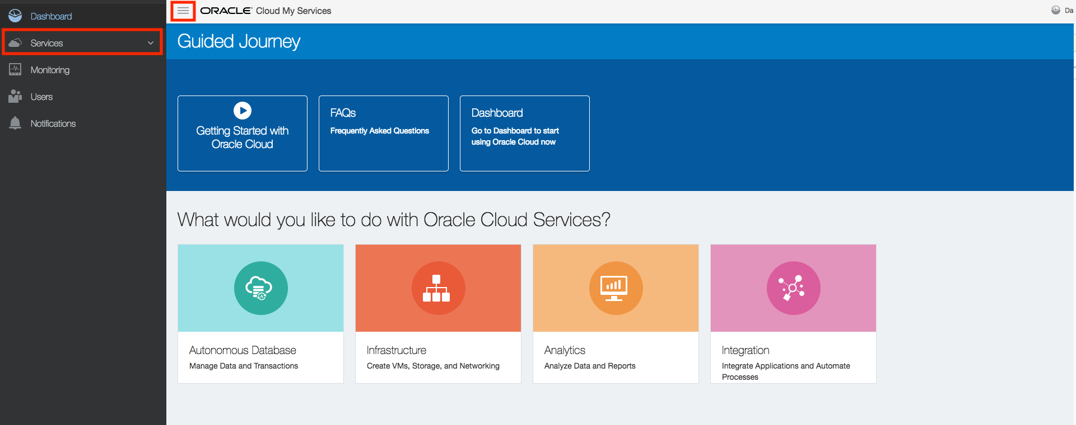

1. Select “Management Cloud” from the Dropdown.

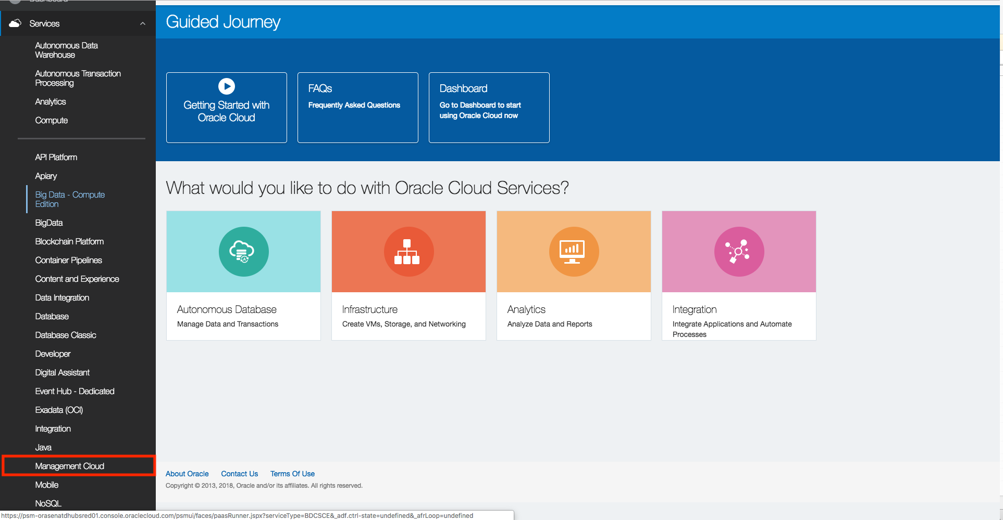

1. Select “Create Instance.”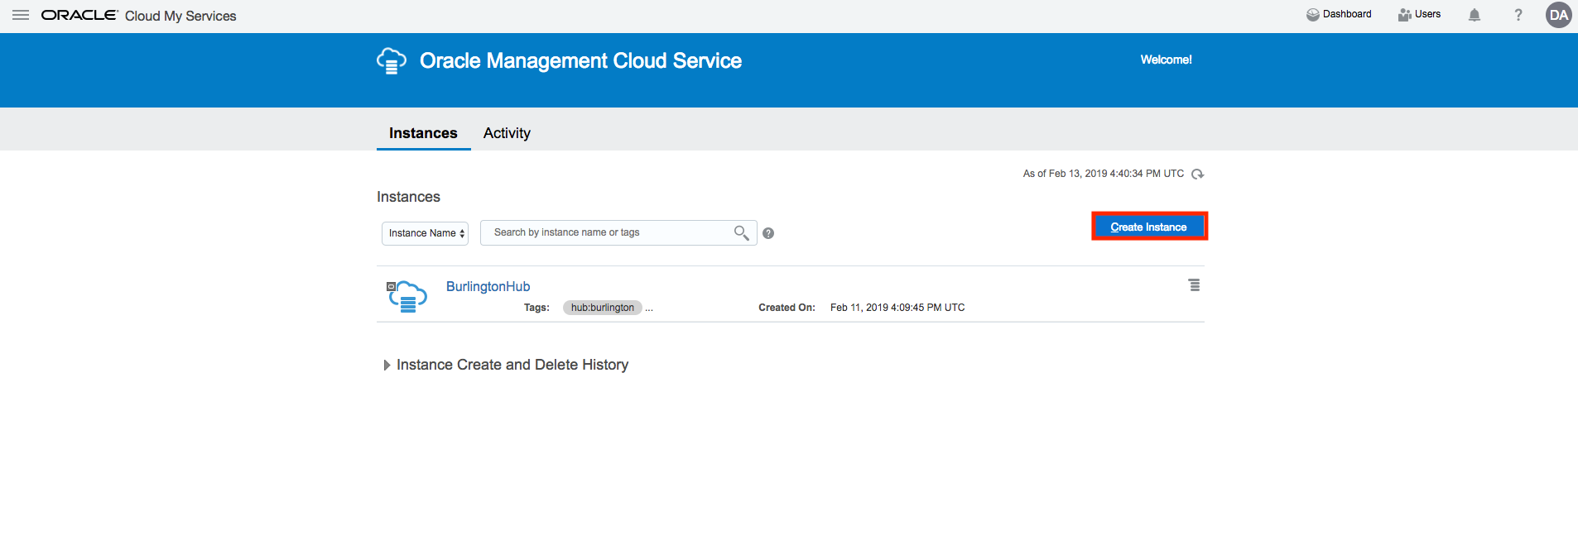
2. Fill in details. Name the environment, choose the notification email and select region. You can optionally choose to tag the instance with relevant metadata if you so choose. Click “Next.”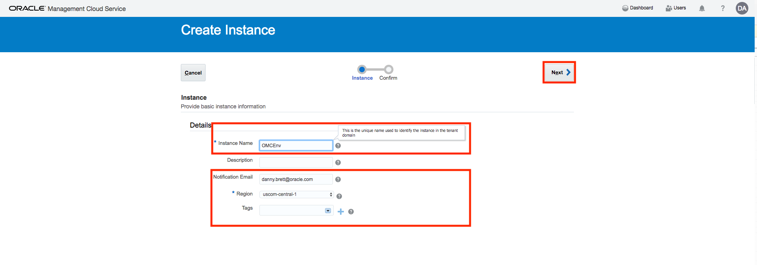
3. Click “Create.” The instance will take approximately 15-20 minutes to provision. 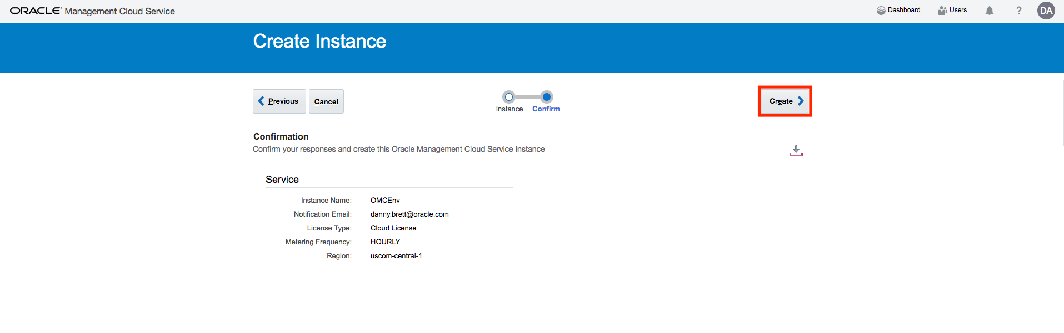

# Prerequisite 2: Collect Infrastructure Details

Collect IP Addresses for Monitored Hosts

1. Determine cloud infrastructure you would like to monitor (for the purposes of this workshop we suggest a minimum of 4).
   1. Examples include Linux hosts, App Servers, databases, etc.
2. Once compiled, collect public IP addresses for each entity.

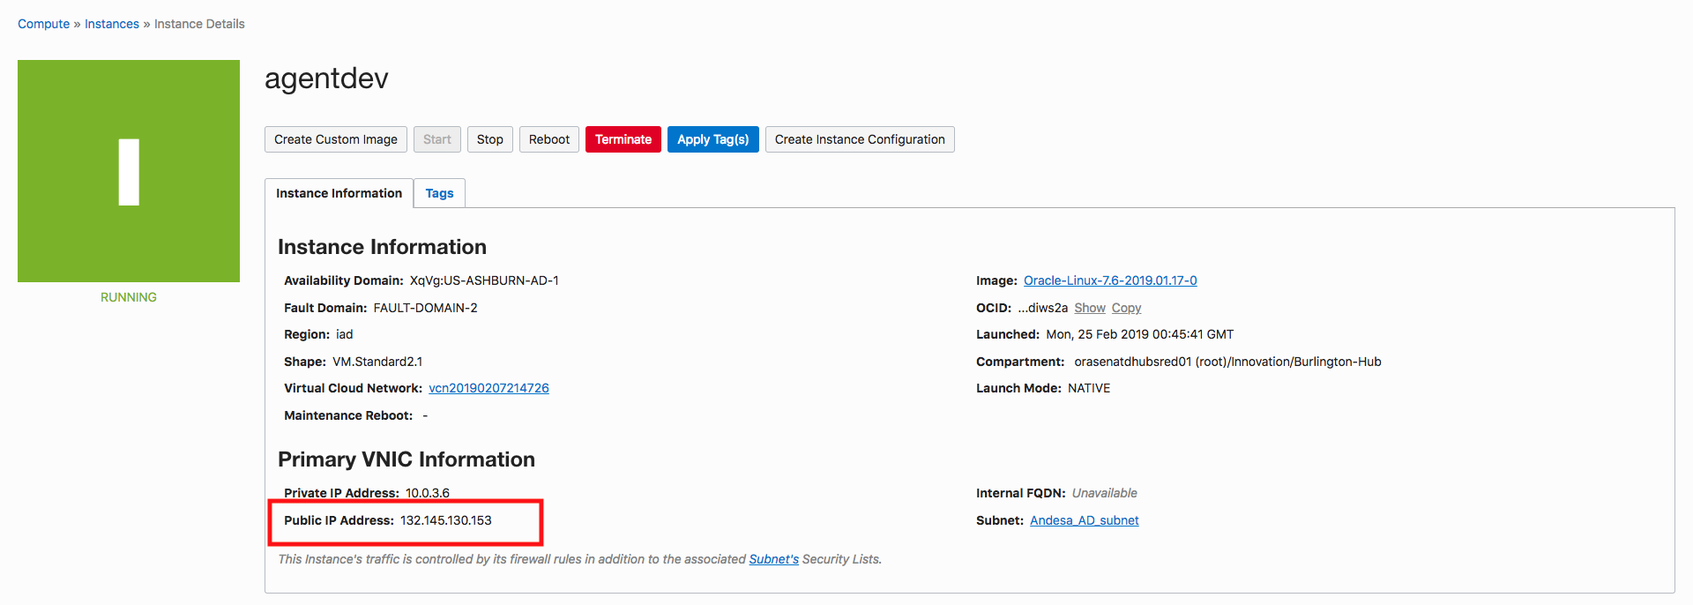

Collect Registration Key, OMC URL, OMC Tenancy ID

1. Login to your cloud environment and select the management cloud service from your console.

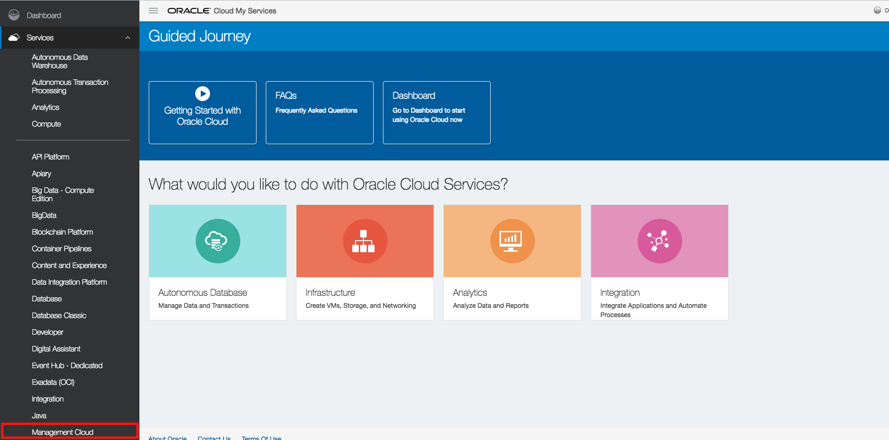

1. You should see your newly created OMC instance. Select the hamburger menu on the right side and click the “OMC URL” option from the dropdown. This will launch your OMC instance.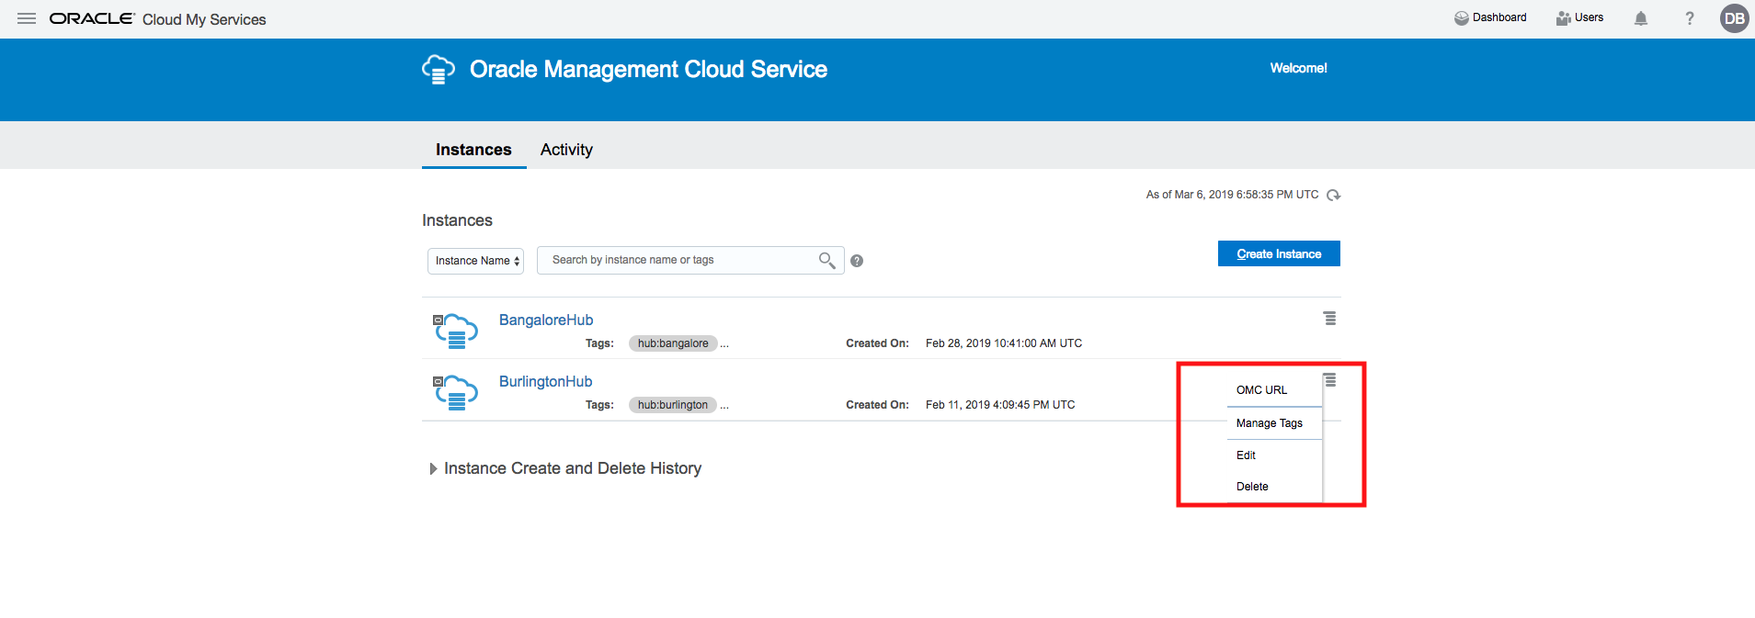
2. From the OMC homepage, select Administration > Agents.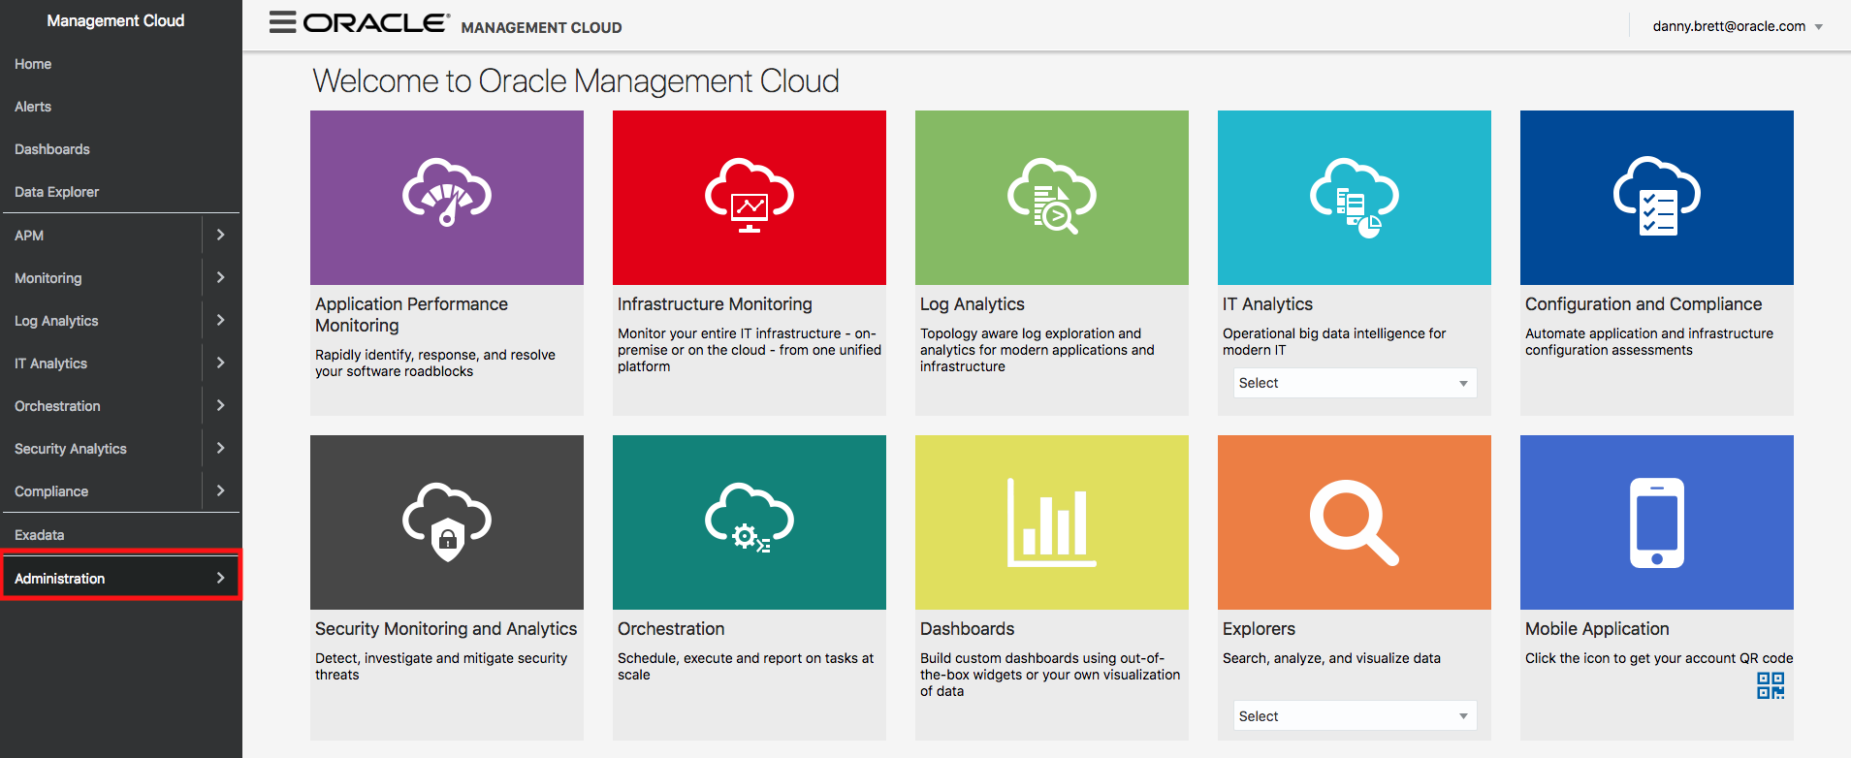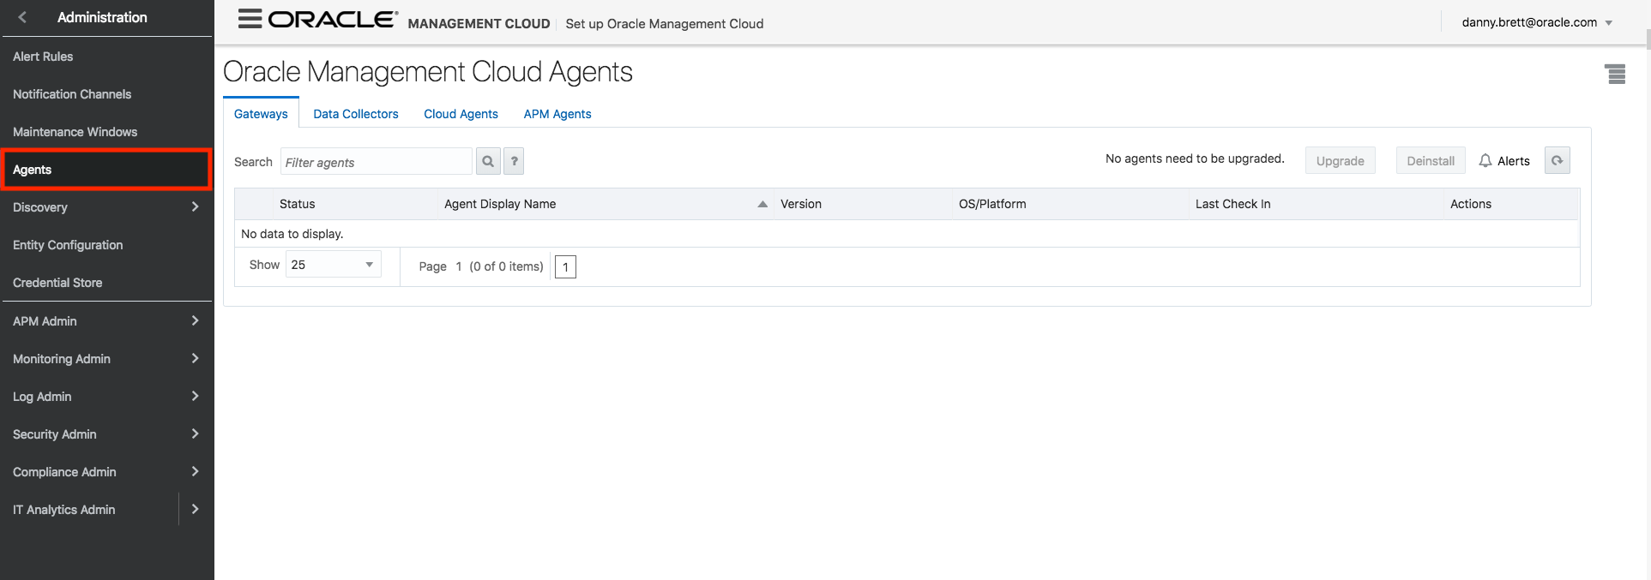
3. Select the Hamburger menu in the upper-right hand corner. Select “Manage Registration Keys.”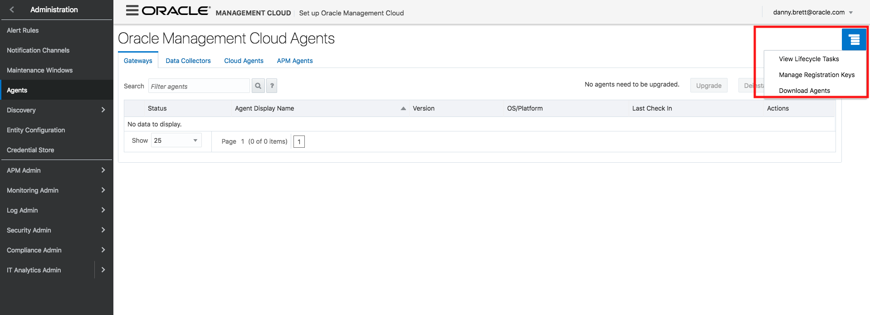
4. If you have just created your environment you will need to create a registration key. Simply enter a name and select “create new key.” **Copy and save the key value**. You will need this for later.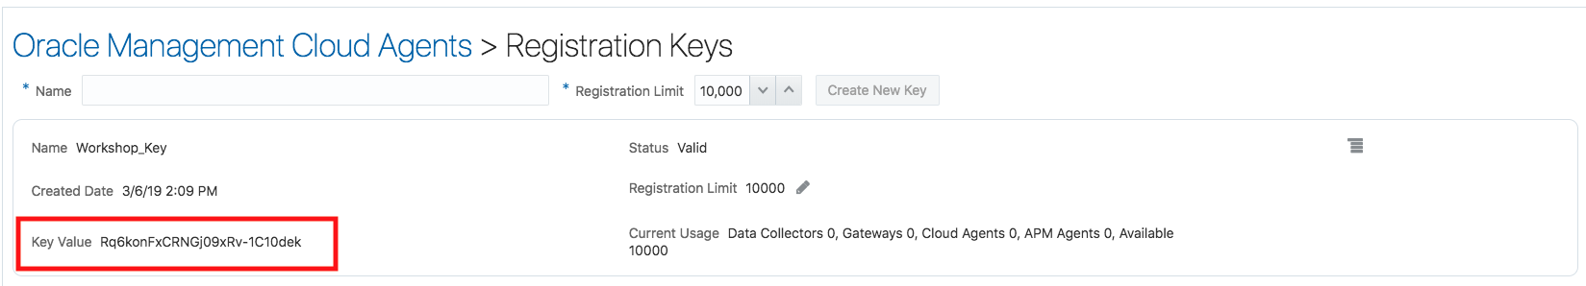
5. Repeat Step 4, but this time choose “Download Agents.” Select “Cloud Agent” from the dropdown. Select the option that matches the host it will be monitoring (EX: for Linux compute host choose “Cloud Agent- Linux 64-bit”). Additionally, **copy and save the TENANT_NAME and OMC_URL.** You will need these later on.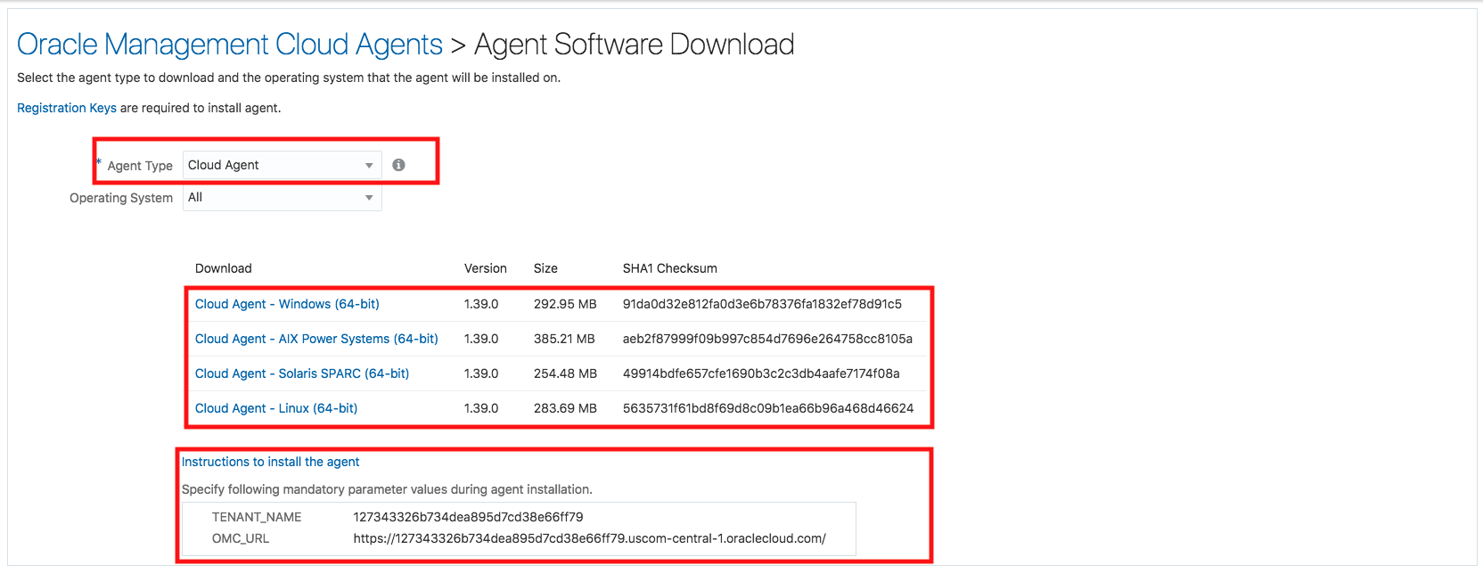

# Prerequisite 3a: Install Cloud Agents on Linux Hosts

Installation Process

1. We will securely copy the contents of the cloud agent over to the host. This can be done using an SFTP client (ex: Cyberduck) or from the command line (we will cover how to do the latter). From the command line execute the following command: “scp –i ~.ssh/KEY_NAME /path/to/cloud/agent/cloudagent.zip opc@IP_ADDRESS_OF_INSTANCE:/home/opc/[1]

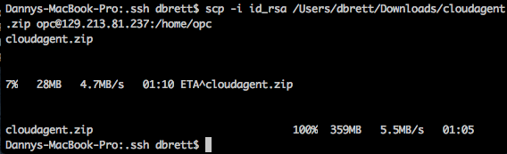

1. Confirm that the software was installed on the host by connecting to the host via ssh. The general command is (from ssh directory) ssh –I KEY_NAME opc@PUBLIC_IP_OF_INSTANCE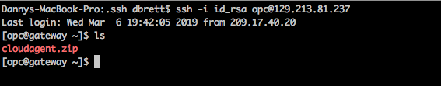

## Unzip the agent. Screen%20Shot%202019-03-06%20at%202.49.14%20PM.png

1. We will modify the agent.rsp file. This can be done from the command line with the “vim command”Screen%20Shot%202019-03-06%20at%202.50.09%20PM.png
2. Press “i” on the keyboard. Then fill in the TENANT_NAME, AGENT_REGISTRATION_KEY, and OMC_URL fields with the information you collected from Prerequisite 2. For AGENT_BASE_DIRECTORY use /home/opc/agent. Leave everything else blank. To save and quit do ESC and then :wq. 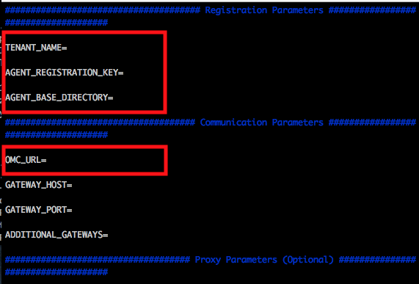
3. Run the AgentInstall script.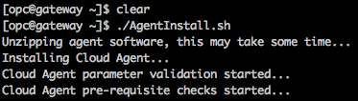

Confirm Agent Is Up & Running

1. Navigate to the bin directory by executing cd agent/agent_inst/bin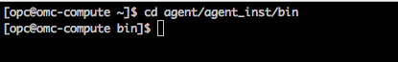
2. OMC has a built in CLI that you can use. To check the status of the agent run ./omcli status agent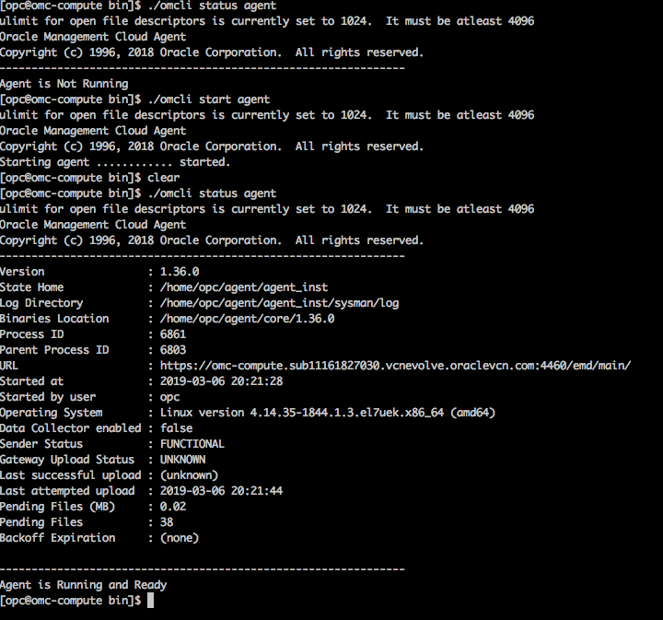
3. We can also confirm that the agent is up and running from the OMC console. Go to Agents > Cloud Agents and if the agent is running you should see it appear with a green arrow.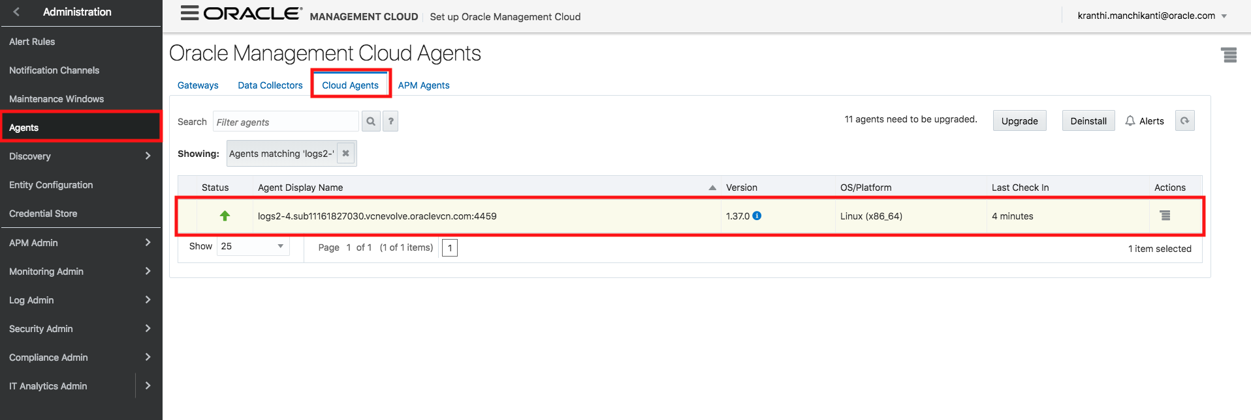

# Prerequisite 3b: Install Cloud Agents on Windows Host

1. We will securely copy the contents of the cloud agent over to the host. We will accomplish this by using an RDP. Open a web console and navigate to your management console. You will download the cloud agent (exactly as in step 6 of prerequisite 2) for the windows host.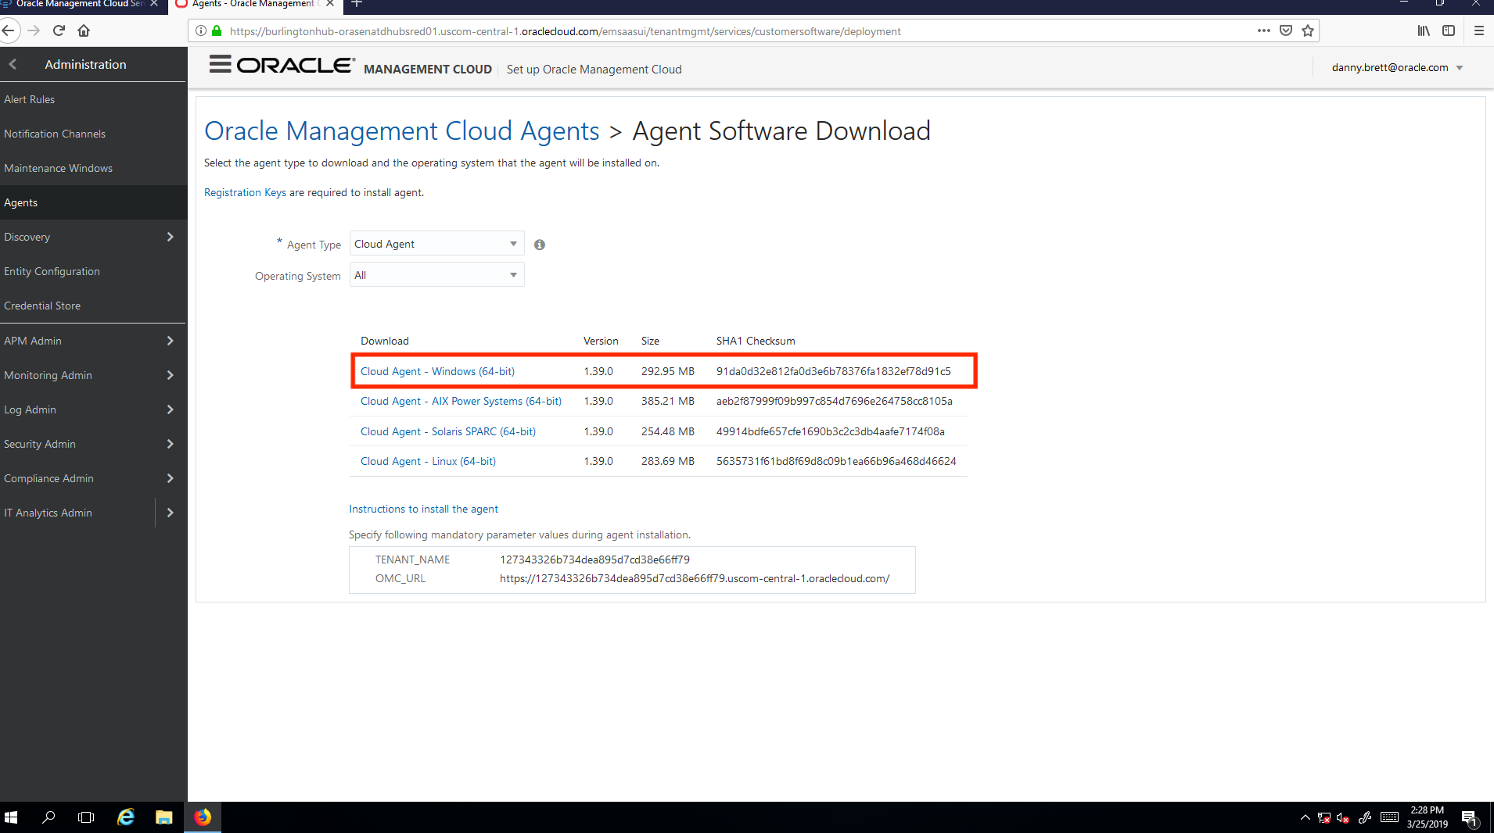
2. Unzip the cloudagent (preferably to the opc folder). Name the new directory something concise (for windows hosts when you install the agent the entire path cannot be longer than 23 characters).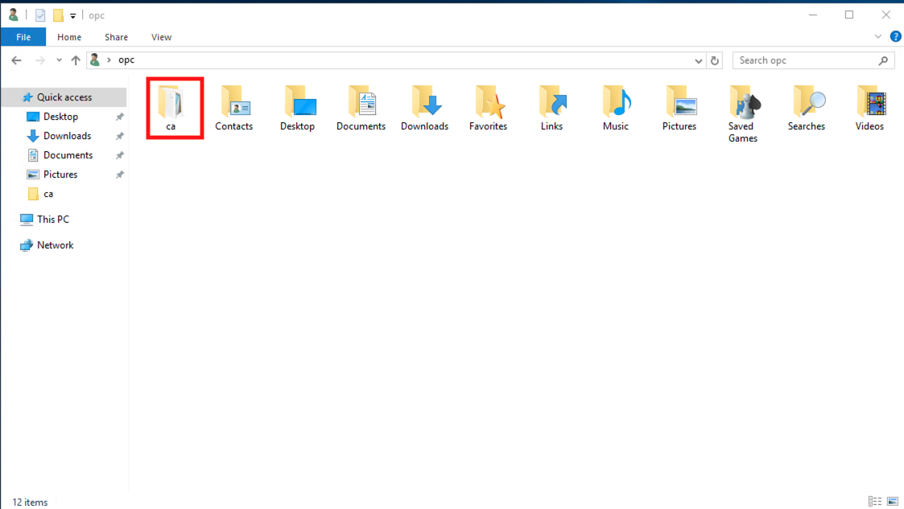
3. Update the agent.rsp file as you did in prerequisite 3a, step 5. Save the file when done.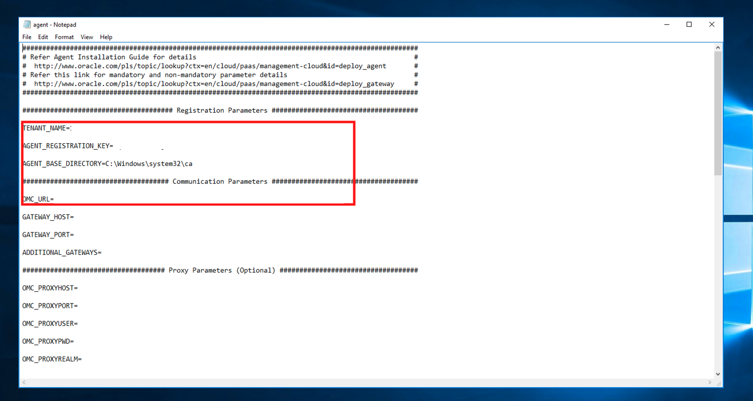
4. Update the hosts file (C:\Windows\System32\drviers\etc. Replace the first example with the IP address of your host and a DNS of your choosing.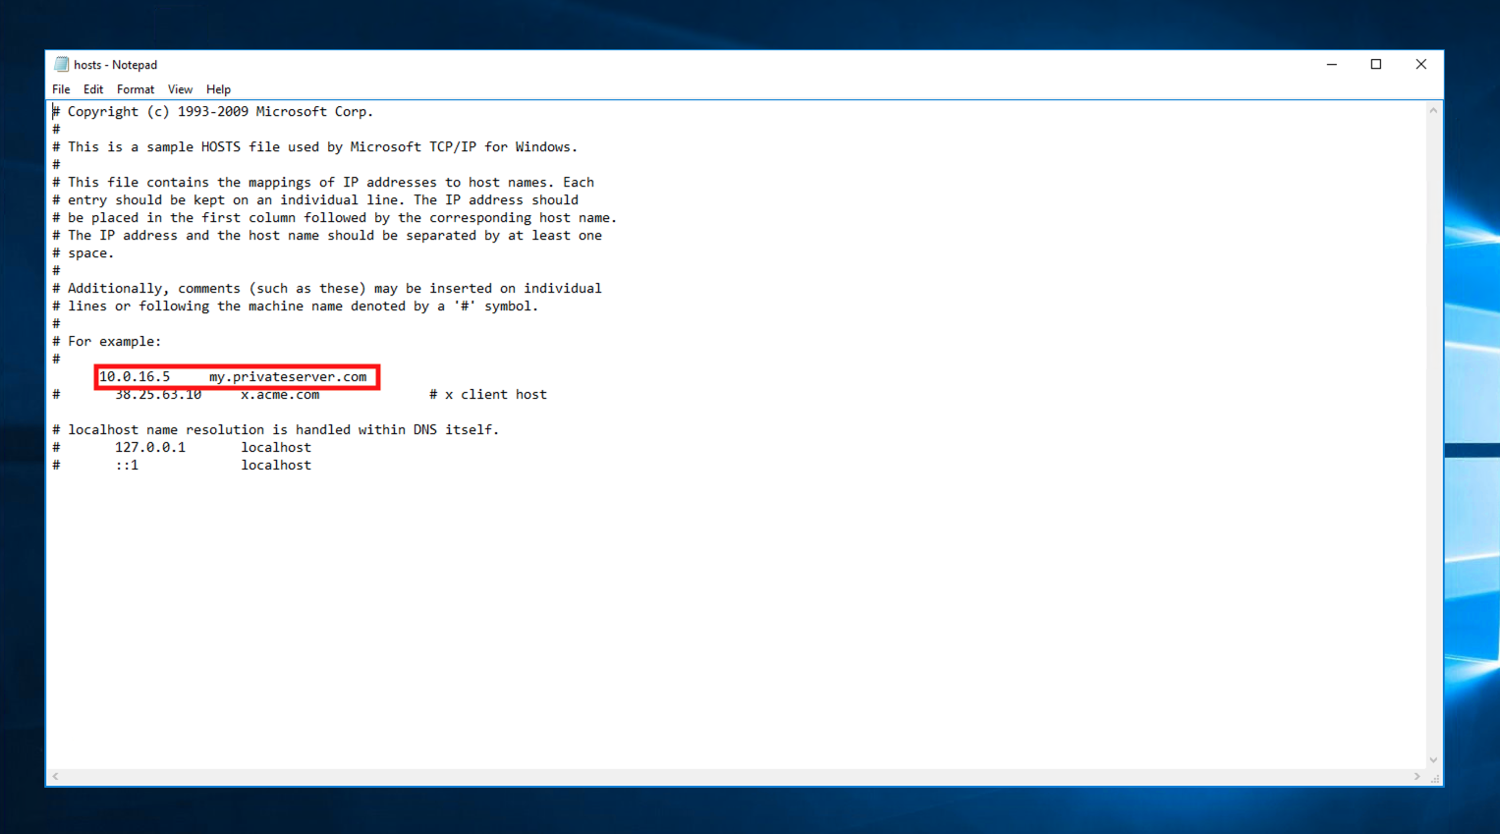
5. Run the AgentInstall.bat script as an administrator. The agent may take a few minutes to boot up. 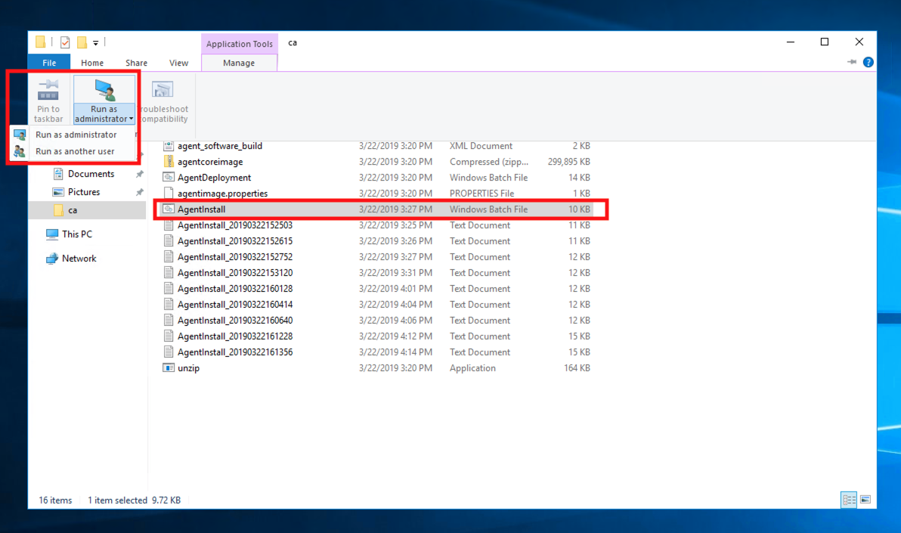
6. Navigate to the OMC console to confirm that the agent is up and running. 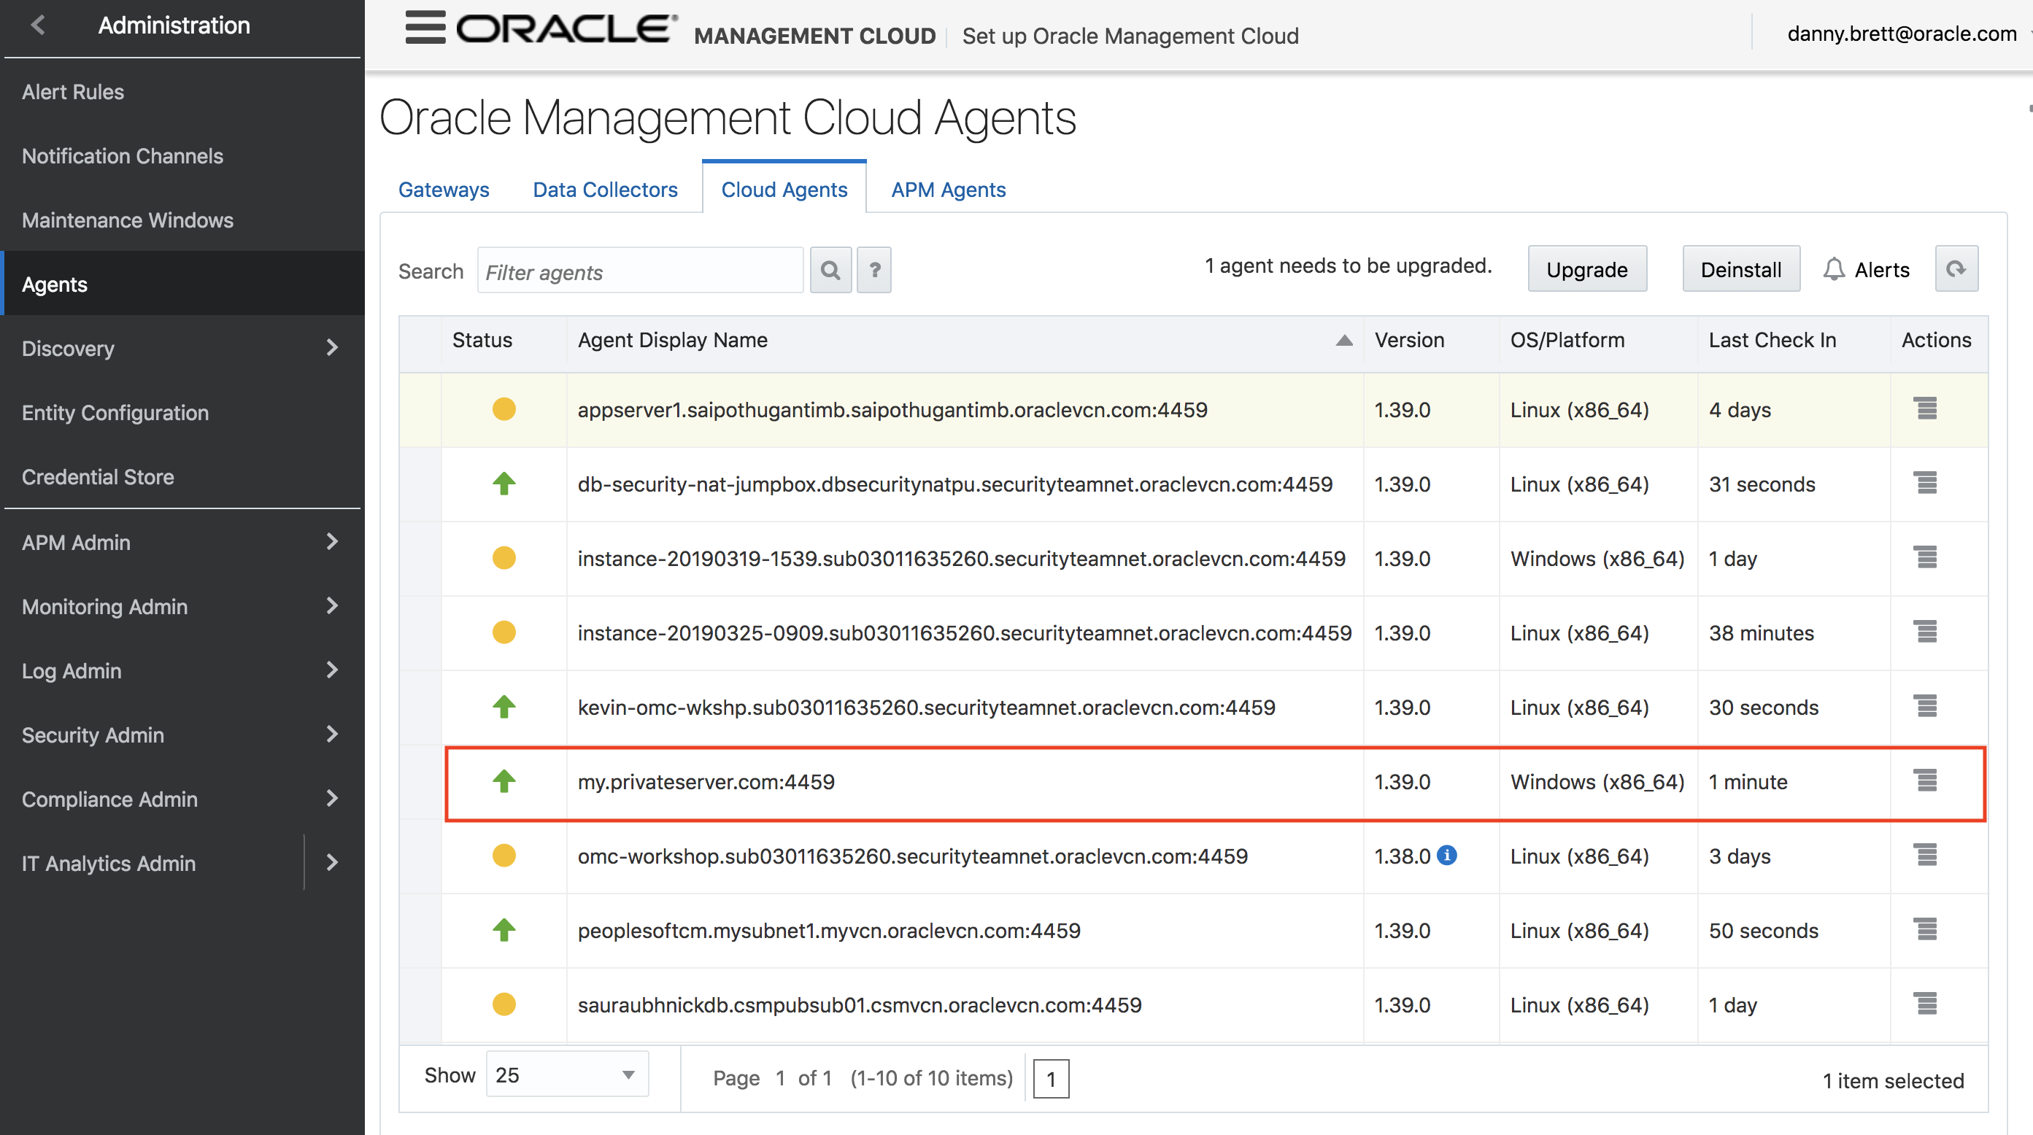

# Prerequisite 4: Enable Log Collection & Associate Entities

1. Navigate to Administrations > Entity Configuration. Select the Licensing tab. Enable Log Collection & SMA Enrichment.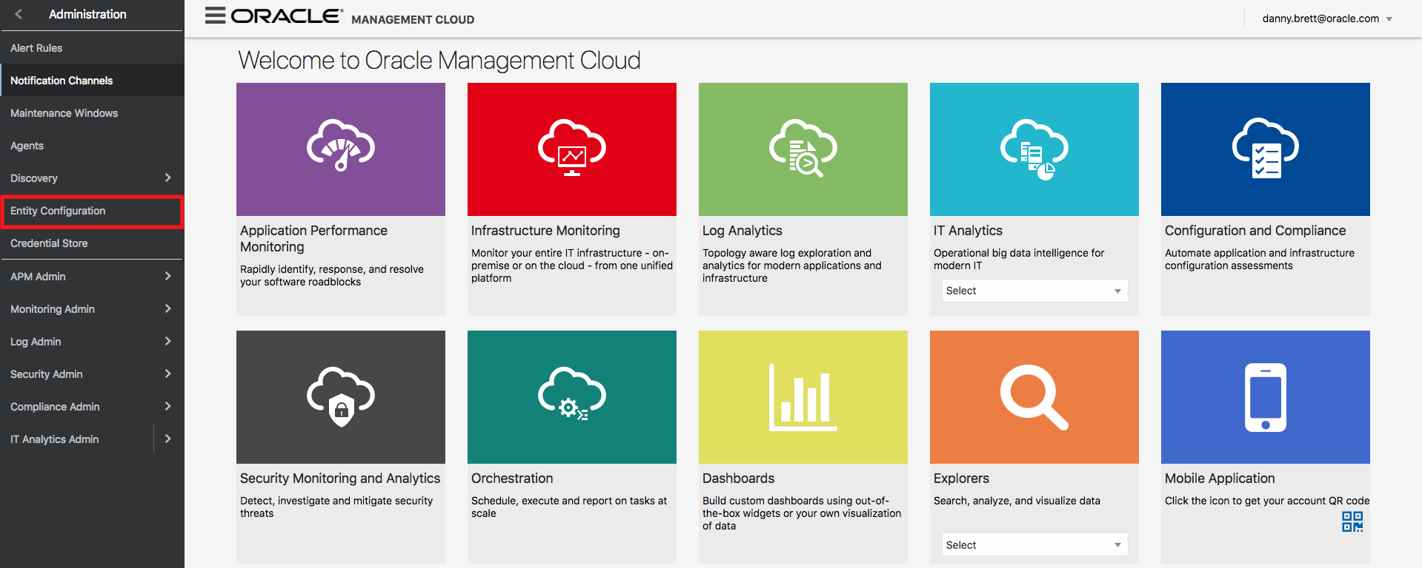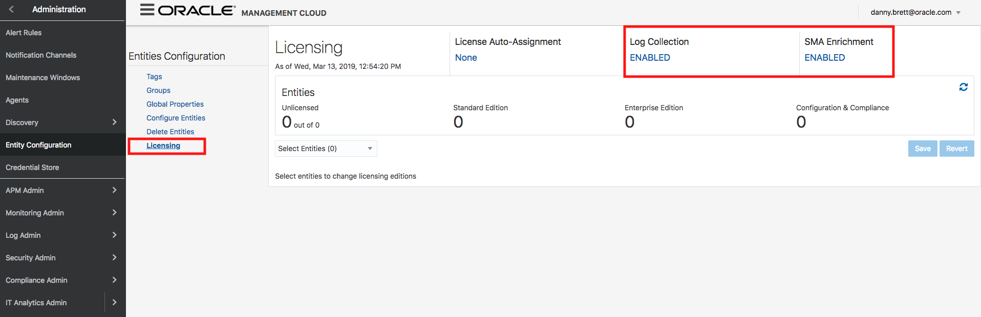
2. Select the Log Admin tab. Click “Entities” & “New Association.”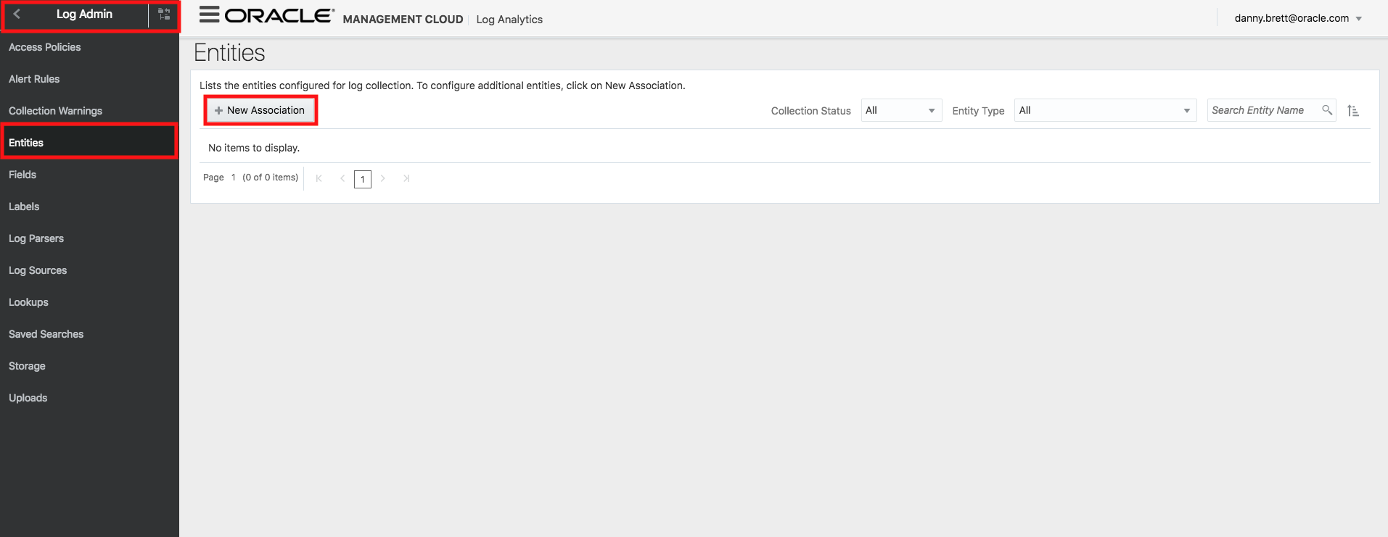
3. Selecting the entity type will depend on the entity you are going to monitor. Options range from Weblogic, Tomcat, & PS Servers to Hosts and much more. Once you have selected the correct entity type, select “Add Entity” which will autopopulate with all available entities (typically cloud or APM agents). Select the appropriate entit(ies).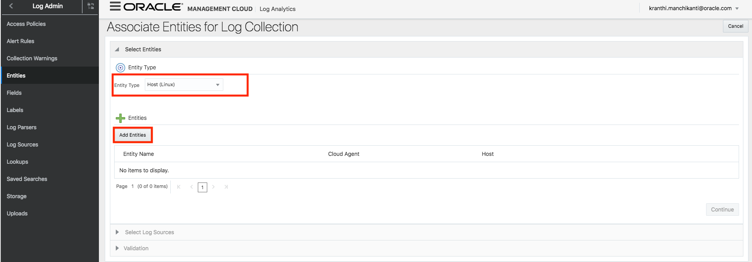
4. Select the appropriate log sources you would like to collect. For cloud agents, collecting syslogs and audit logs is highly recommended. You can also choose to select all available logs. Select “Associate entities.”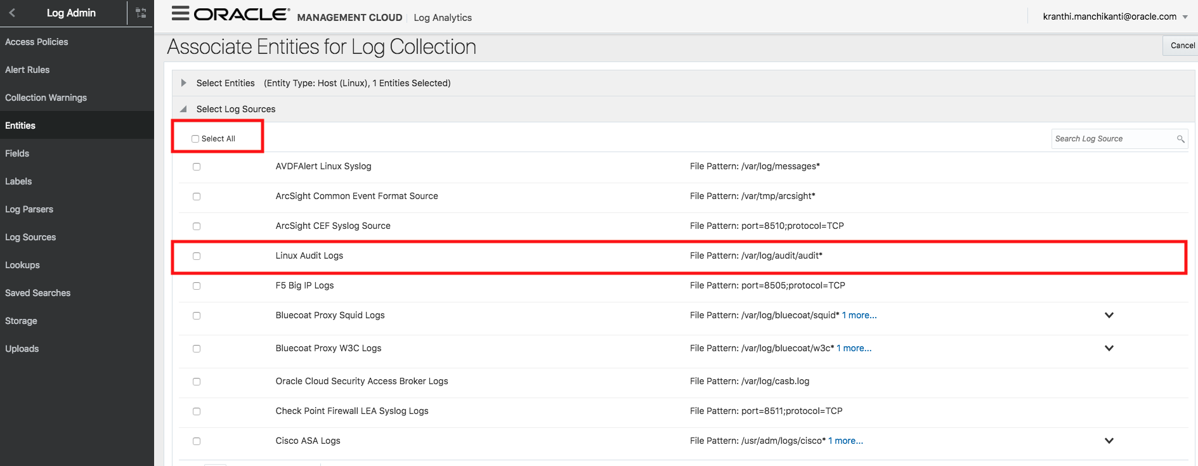
5. It can take up to 15 minutes for the agent to start pulling logs into the log explorer. Refer to the log explorer page frequently until you see records materialize.

# Prerequisite 5: Install APM Agents (Apache Tomcat on Linux)

## Navigate to the agents page as you did prerequisite 3a, step 6. Download the APM Java Agent.Screen%20Shot%202019-03-25%20at%2010.56.20%20AM.png

1. Secure Copy the APM agent to your Apache Tomcat server[2]. Unzip the agent. You should see the following files (albeit with different permissions).
2. Set the CATALINA_HOME path to your tomcat directory. This will be important when you provision the agent. 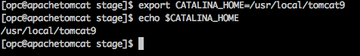
3. Check the permissions on your tomcat server. Make sure that the same user that installed the tomcat server is running executes the steps from 5 onward.
4. Change the permissions on the ProvisionAPMJavaAsAgent.sh file so it’s executable. Then provision the agent using ./ProvisionApmJavaAsAgent.sh –d ${CATALINA_HOME} –no-wallet. Screen%20Shot%202019-03-25%20at%2011.13.20%20AM.png
5. Enter the registration key when prompted. Once provisioning is complete navigate to your tomcat folder. Make a copy of the catalina.sh file (in bin folder) and name it catalina.sh.orig. Screen%20Shot%202019-03-25%20at%2011.17.54%20AM.png
6. Modify the catalina.sh file with the following line: CATALINA_OPTS=”$CATALINA_OPTS –javaagent:${CATALINA_HOME}/apmagent/lib/system/ApmAgentInstrumentation.jar. Alternatively you can add this line (put export in front) to a new file called “setenv.sh.” If there are issues adding this line to the catalina.sh file, remove it and create the setenv.sh file.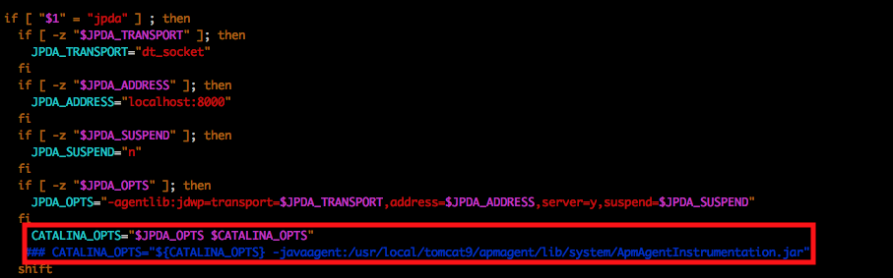
7. Restart the tomcat server by running the shutdown & startup scripts. 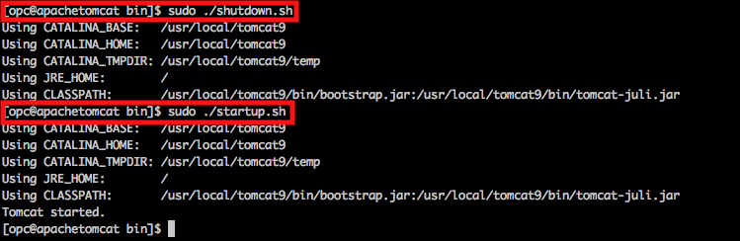
8. As in prerequisite 2, step 9 check to see that the APM agent is up and running within the OMC Console.

|  |  |
| --- | --- |
|  |  |
|  | **Oracle Corporation, World Headquarters Worldwide Inquiries**  500 Oracle Parkway Phone: +1.650.506.7000  Redwood Shores, CA 94065, USA Fax: +1.650.506.7200 |
| Connect with us  blogs.oracle.com/oracle  facebook.com/oracle  twitter.com/oracle  oracle.com  Connect with us  blogs.oracle.com/oracle  facebook.com/oracle  twitter.com/oracle  oracle.com  Connect with us  blogs.oracle.com/oracle  facebook.com/oracle  twitter.com/oracle  oracle.com | Copyright © 2018, Oracle and/or its affiliates. All rights reserved. This document is provided for information purposes only, and the contents hereof are subject to change without notice. This document is not warranted to be error-free, nor subject to any other warranties or conditions, whether expressed orally or implied in law, including implied warranties and conditions of merchantability or fitness for a particular purpose. We specifically disclaim any liability with respect to this document, and no contractual obligations are formed either directly or indirectly by this document. This document may not be reproduced or transmitted in any form or by any means, electronic or mechanical, for any purpose, without our prior written permission.  Oracle and Java are registered trademarks of Oracle and/or its affiliates. Other names may be trademarks of their respective owners.  Intel and Intel Xeon are trademarks or registered trademarks of Intel Corporation. All SPARC trademarks are used under license and are trademarks or registered trademarks of SPARC International, Inc. AMD, Opteron, the AMD logo, and the AMD Opteron logo are trademarks or registered trademarks of Advanced Micro Devices. UNIX is a registered trademark of The Open Group. 0116  Document Title  AUGUST 2018  Author: Daniel Brett |
|  | |  | | --- | |  | |

1. Note that this process will be modified if the instances have a private IP address. We can install the agent through a variety of different mechanism (e.g. VPN/SSL Connection, Jumpbox, etc).
2. Must be Tomcat 6 or newer.